Minimum Spanning Trees and integration with species distributions to identify priority connectivity corridors
Summary document
Prepared by:
Andrew Habrich, Carina Rauen Firkowski, Bronwyn Rayfield, Andrew Gonzalez

Overview
This document summarizes the methods and preliminary results developed to identify species-specific networks of connections among protected areas in southern Quebec using minimum spanning trees, and to integrate these networks with species distribution models. The work is carried out in collaboration with the Ministère de l’Environnement, de la Lutte contre les changements climatiques, de la Faune et des Parcs (MELCCFP). As of October 2026, five of the ten focal species have been analysed (golden eagle, short-eared owl, bobolink, pileated woodpecker and American marten); results for the remaining five species will be added as they are completed.

Methods
Approach: A minimum spanning tree (MST) is the subset of all possible links that connects every node of a network at the lowest total cost without forming loops or backtracking (Prim 1957). When applied to protected areas (PA), it identifies a parsimonious backbone of least-cost corridors that links the whole protected area network (Theobald et al. 2012; Barnett and Belote 2021). Previous applications of MST for protected area design have been species-agnostic; We use information on species-specific dispersal ability and habitat requirements to build a separate tree for each focal species.
For each species we:
- Identified the pairs of protected areas within species-specific dispersal range.
- Parameterized landscape resistance to movement based on literature review.
- Computed the accumulated movement cost between each PA pair.
- Extracted the species-specific minimum spanning tree.
- Traced the least-cost path of each tree link,
- Smoothed the paths to identify potential movement corridor density.
- Overlaid that surface with the species’ distribution model.
Figures 1 and 2 illustrate each step for American marten, which is used as the worked example throughout this document.
Study area and protected areas:
The study area comprised all of Quebec south of 49° N. Analyses were run over a larger modelling extent that also covers adjacent parts of Ontario, New Brunswick, New York, Vermont, New Hampshire and Maine, so that connections crossing provincial and national borders are not truncated. Protected-area polygons from provincial, federal and state registries were merged, large aquatic protected areas were removed, and polygons that overlapped or lay within 50 m of each other were joined into single patches. For the purposes of analyses, and to capture areas of ecological relevance to the focal species, only patches of at least 5 km² were retained (557 patches, 50,893 km² in total). All distances between patches were measured edge-to-edge, between the nearest points of the two patch boundaries, rather than between centroids, because movement inside a protected area is not a connectivity cost and a centroid is not an ecologically meaningful starting point for movement within and between large or irregular patches.
Focal species and dispersal:
Ten focal species spanning a range of taxa, dispersal abilities and habitat associations were selected in workshops with ministry experts. For each species, median natal dispersal distance, dispersal mode and the suitability of each land-cover type, forest type and forest age class were compiled from a literature review (Supplementary Table S1). To date, five species have been analysed: golden eagle (Aquila chrysaetos), short-eared owl (Asio flammeus), bobolink (Dolichonyx oryzivorus), pileated woodpecker (Dryocopus pileatus) and American marten (Martes americana). The probability of dispersal between two patches separated by distance d was modelled with a negative exponential kernel, p(d) = exp(−αd), with α = ln 2 / D₅₀ so that p = 0.5 at the median dispersal distance D₅₀ (Albert et al. 2017). Pairs of patches with dispersal probability p ≥ 0.05 were retained as candidate links (Figure 1A–B). Because the short-eared owl’s median dispersal distance (575 km) gives a search radius larger than the study area, its candidate links were limited to each patch’s 20 nearest neighbours plus the links of the straight-line spanning tree, which keeps the network connected while limiting computation requirements (Supplementary Section S2).
Landscape resistance:
Resistance to movement was mapped on a 30 m grid from a harmonized land-cover map (including roads and railways) and from forest type and forest age maps, following the doubling scale of Albert et al. (2017). Each cell receives an ordinal rank, where 0 is the most suitable, and resistance = 2^{rank}, so each step doubles the cost of crossing a cell. Ranks for land-cover types whose suitability differs among species (agriculture, open and forested wetlands, grassland, shrubland and barren land) came from the species’ suitability ratings (highly suitable = 0, suitable = 2, poorly suitable = 3, unsuitable = 5). Urban areas, roads and railways received high ranks common to all species (4–6), and water a shared rank adjusted for dispersal mode. In forest cells, the rank combined the species’ rating of the forest type (coniferous, deciduous or mixed) with a penalty for each age-class step away from the species’ preferred forest ages. Resistance therefore ranges from 1 in optimal habitat to 64 in urban areas (Figure 1C; scoring rules in Supplementary Section S3).
Cost distance and minimum spanning tree:
For each candidate pair, accumulated cost distance was computed with the terra package (Hijmans 2026), treating the whole origin patch as the source and taking the lowest accumulated cost over the destination patch. Cost is expressed in cost-weighted distance (resistance × metres); because the lowest resistance is 1, the cost of a link is never less than its straight-line length, and the ratio of the two (the detour factor) is the mean resistance met along the link. Candidate links, weighted by cost distance, formed one graph per species, from which the minimum spanning tree was extracted with Prim’s algorithm (Prim 1957) in the igraph package (Csardi and Nepusz 2006). Where some patches had no candidate partner within dispersal range of the rest of the network, the graph is split into disconnected components and the result is a minimum spanning forest, with one tree per component (Figure 1D).
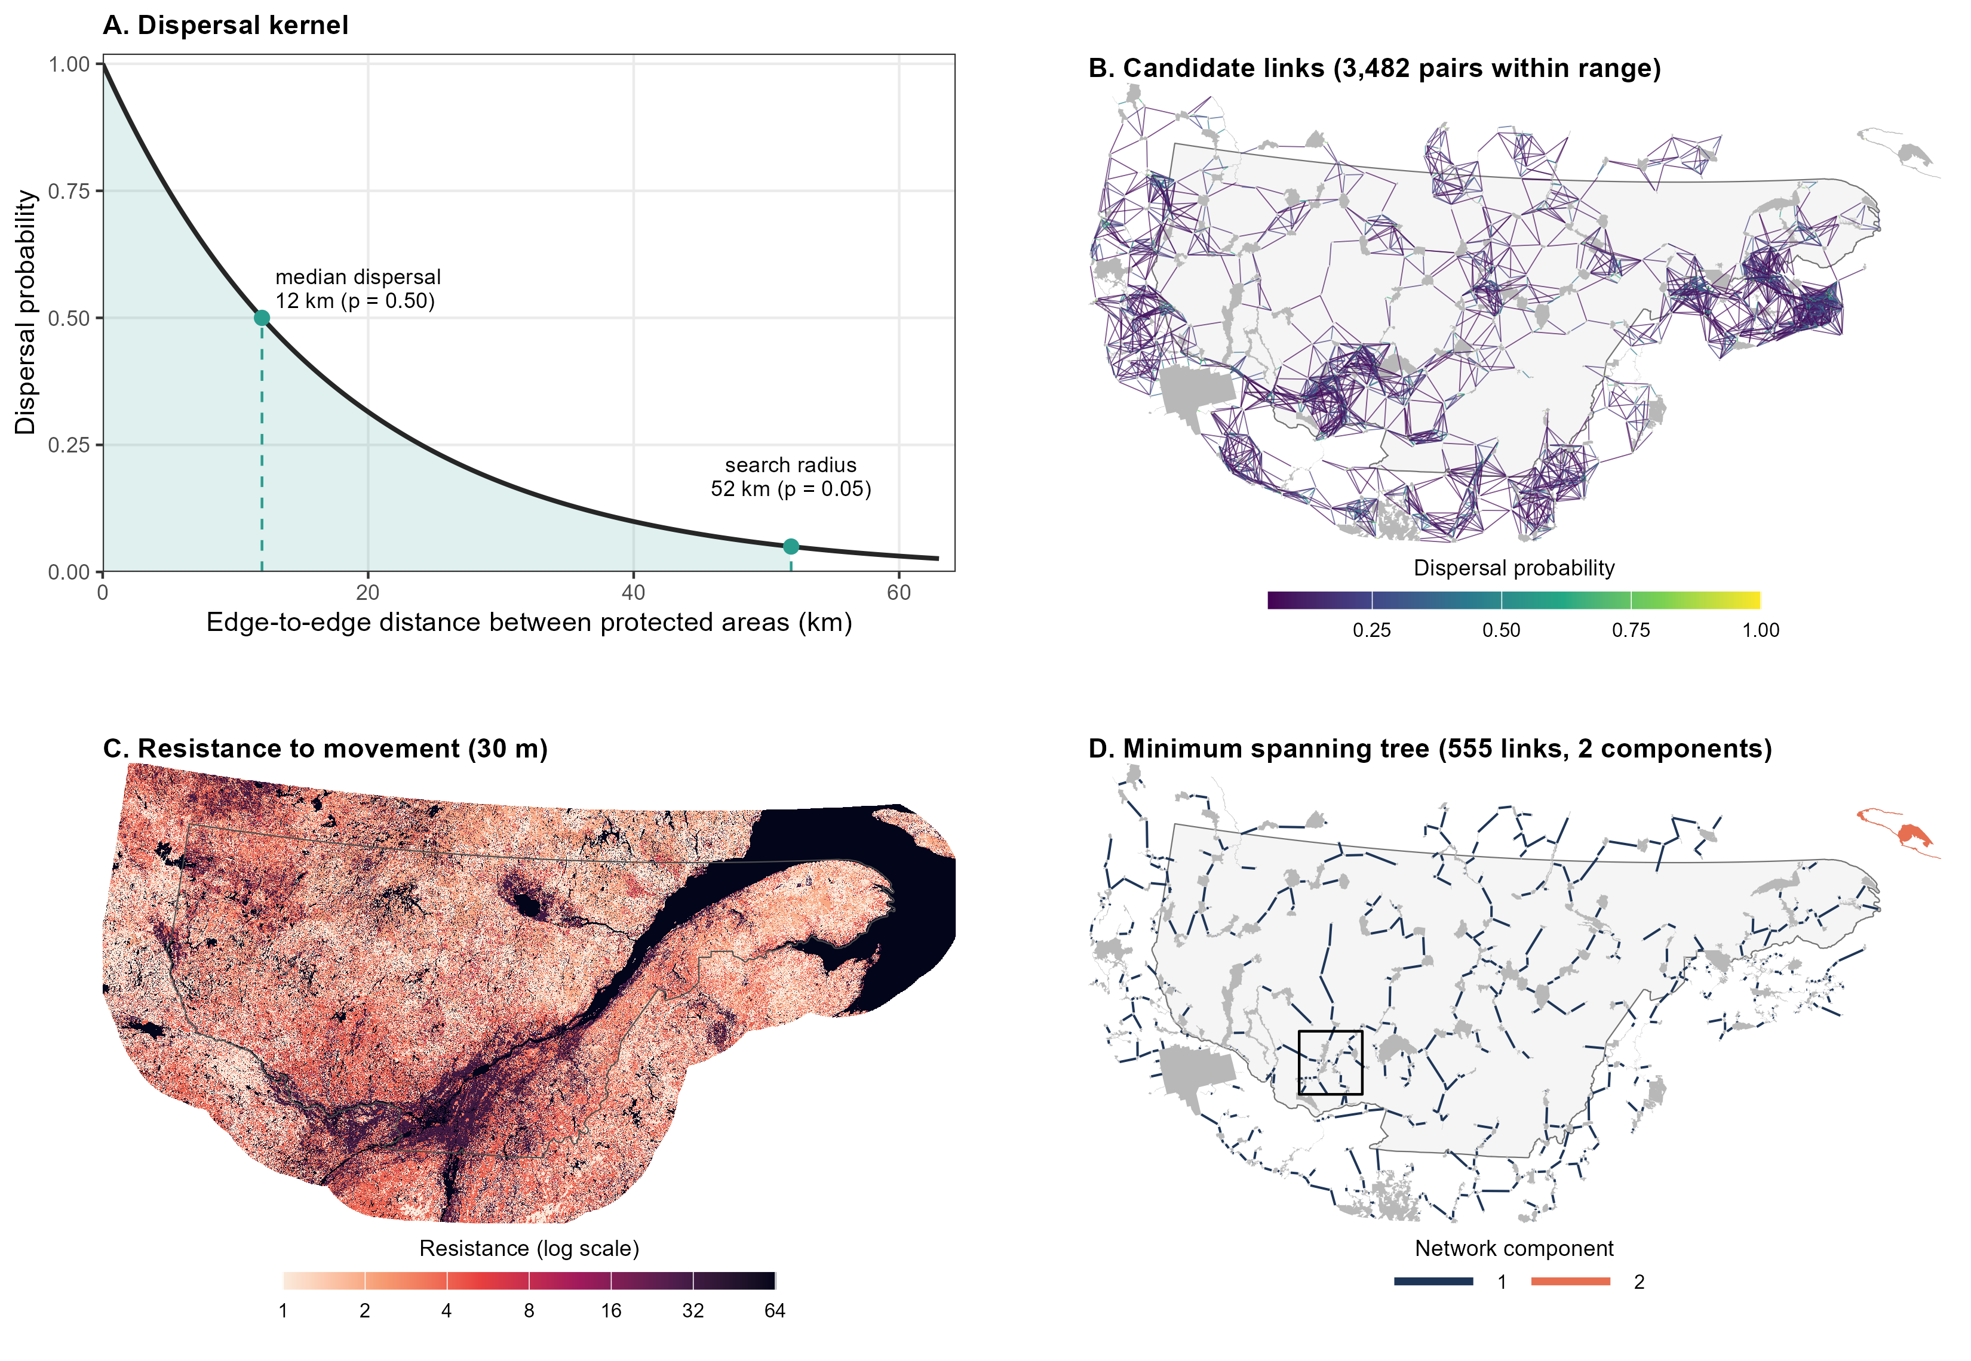
Figure 1. Building the protected-area network for American marten, the worked example. (A) Negative exponential dispersal kernel, with p = 0.5 at the median dispersal distance (12 km); pairs of protected areas closer than the search radius (52 km, p = 0.05) become candidate links. (B) The 3,482 candidate links, drawn edge-to-edge between protected-area boundaries and coloured by dispersal probability. (C) Resistance to movement on the 30 m grid (light = suitable forest; dark = water, urban areas and major roads). (D) Minimum spanning tree selected from the candidate links by cost distance. A small group of protected areas in the far north-east forms a second component (orange). The box marks the window shown in Figure 2. Grey shapes are protected areas (≥ 5 km²); the outline is the study area.
Corridors and integration with species distributions:
Each tree link was traced as a least-cost path between the nearest boundary points of its two patches, across the species’ resistance surface, using the gdistance package (Adriaensen et al. 2003; van Etten 2017; Figure 2A). As dispersers do not follow a single optimal route, the paths were rasterized and smoothed with a Gaussian kernel whose standard deviation equals the mean of the species’ dispersal kernel (D₅₀ / ln 2, with D₅₀ capped at 100 km). This matches the bandwidth used in resistant-kernel connectivity models (Compton et al. 2007) and gives a corridor density surface (length of corridor per unit area) for each species (Figure 2B; Supplementary Figure S1). Corridor density was overlaid with the species distribution models from Eckert et al. (WHAT CITATION?). The lowest 10% of corridor density values were discarded as noise, both surfaces were rescaled to 0–1, and their product identifies areas that are both within dense corridors and likely to be occupied by the species (Figure 2C–D).
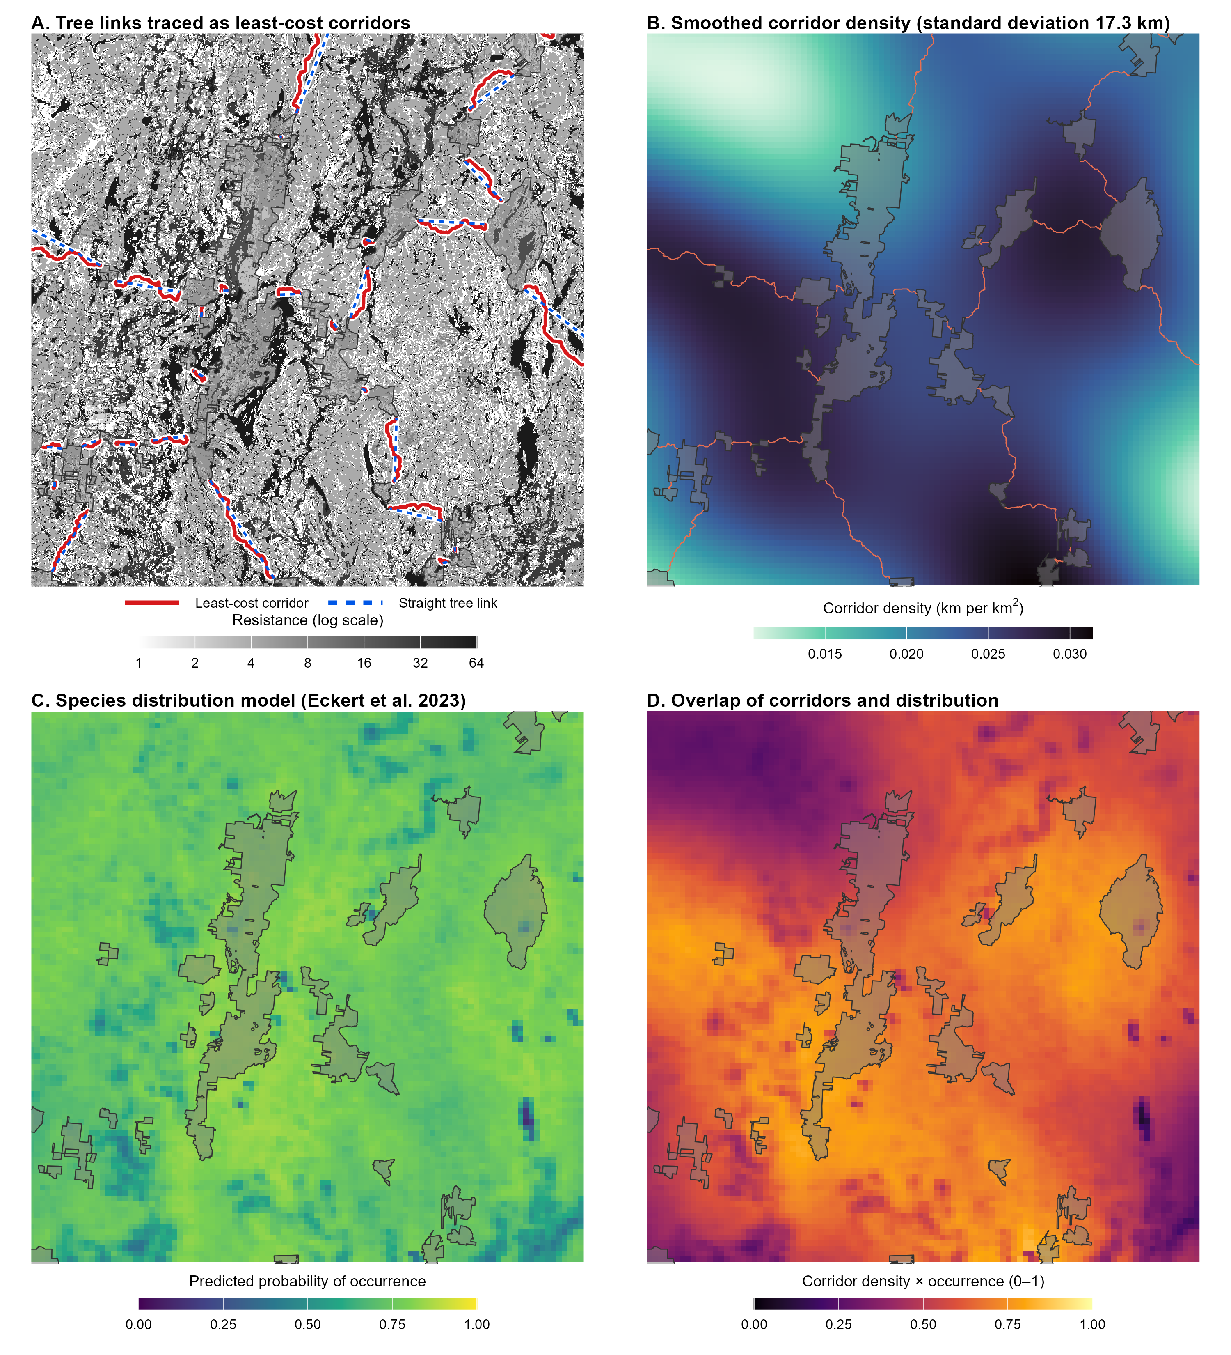
Figure 2. From tree links to corridors and their overlap with the species distribution, shown for a 100 km × 100 km window of the American marten network (box in Figure 1D). (A) Each tree link (dashed blue, straight between the nearest boundary points) is traced as a least-cost corridor (red) across the resistance surface (greyscale; dark = high resistance). (B) Corridors smoothed with a Gaussian kernel (standard deviation 17.3 km) into a corridor density surface. (C) Current predicted probability of occurrence from the species distribution model of Eckert et al. (XXXX). (D) Product of rescaled corridor density and probability of occurrence, after the lowest 10% of corridor density values are removed. Protected areas are shown in transparent grey.
Summary statistics:
For each species we report the number of candidate links, the number of tree links and connected components, the total straight-line length and total cost of the tree, the distribution of link lengths and detour factors, the dispersal probability of tree links (from straight-line distance) and the equivalent connected area (Saura et al. 2011). The equivalent connected area is the size of a single, fully connected protected area that would provide the same probability of connectivity as the network. We calculate it here along the tree links and expressed as a percentage of the total protected area. All analyses were carried out in R (R Core Team 2026) with the sf (Pebesma 2018), terra, igraph and gdistance packages.
Sensitivity analysis:
We tested how sensitive the trees, corridors and distribution overlap are to the two uncertainties, median dispersal distance and the contrast of the resistance scale, by changing one at a time from the baseline model produced from the comprehensive literature review (Beier et al. 2009; Rayfield et al. 2010). Dispersal distance was multiplied by 0.5, 0.75, 1.33 and 2, which moves both the dispersal cutoff for candidate links and the width of corridor smoothing. Resistance contrast was varied by raising every resistance value to the power m (resistance = 2^{m × rank}, with m = 0.5, 0.75, 1.25 and 1.5; baseline m = 1). This keeps the order of land-cover types but makes the differences between them smaller (m < 1) or larger (m > 1). This gave eight scenarios per species (40 total scenarios, so far with the 5 currently analysed species). Each scenario was compared with the baseline on five measures:
- The proportion of tree links shared (Jaccard similarity).
- The change in the number of components and in total tree length, and
- The share of corridor length lying within 1 km of the other network’s corridors (averaged over both directions; Beier et al. 2009).
- The overlap surfaces were compared by their similarity (Schoener’s D, where 1 = identical; Warren et al. 2008).
- Similarity in overlap of their top 10% of cells (hotspots).
Suitability ratings of individual habitat types were not varied (design in Supplementary Section S5).

Results
Minimum spanning trees have been built for five of the ten focal species (Table 1). Each network spans the same 557 protected areas (50,893 km²). The number of candidate links within dispersal range increased with dispersal distance, from 3,482 for American marten to 21,759 for golden eagle; the short-eared owl had fewer (6,592) because its candidate links were restricted to 20 nearest neighbour patches. The short-eared owl, golden eagle and bobolink networks each formed a single tree. The pileated woodpecker and American marten networks each split into two components: protected areas totalling 1,342 km² (2.6% of the total protected area) had no candidate partner within dispersal range of the rest of the network. These unconnected protected areas are located on Anticosti Island, which is separated from mainland Quebec in the Gulf of the St. Lawrence.
Table 1. Summary of the species-specific minimum spanning trees linking 557 protected areas (≥ 5 km²) in southern Quebec. Species are ordered by decreasing median dispersal distance.
Statistic | Short-eared owl |  | Golden eagle | Bobolink | Pileated woodpecker | American marten
Median dispersal distance (km) |  | 575 | 41 | 19 | 12.35 | 12
Search radius (km)ª |  | 2,485^{b} | 177 | 82 | 53 | 52
Candidate links |  | 6,592 | 21,759 | 6,798 | 3,639 | 3,482
Tree links |  | 556 | 556 | 556 | 555 | 555
Connected components |  | 1 | 1 | 1 | 2 | 2
Protected area in largest component (%) |  | 100 | 100 | 100 | 97.4 | 97.4
Total straight-line length (km) |  | 6,655 | 6,034 | 6,537 | 5,956 | 6,140
Total cost (thousand cost-weighted km)^{c} |  | 52.2 | 18.6 | 98.3 | 12.2 | 18.2
Mean resistance along the tree (total cost / total length) |  | 7.8 | 3.1 | 15.0 | 2.0 | 3.0
Link length, median (quartiles) (km) |  | 7.6 (2.3–15.9) | 7.4 (2.2–15.8) | 7.4 (2.3–16.1) | 7.5 (2.3–15.7) | 7.7 (2.4–16.5)
Longest link (km) |  | 83.5 | 71.5 | 77.9 | 52.8 | 51.1
Detour factor, median (quartiles)^{d} |  | 10.8 (6.5–16.0) | 2.9 (2.2–4.1) | 18.9 (13.3–26.7) | 1.6 (1.3–2.2) | 1.8 (1.4–2.9)
Largest detour factor |  | 74.0 | 21.2 | 74.0 | 20.8 | 67.1
Cost of the most expensive path through the tree (thousand cost-weighted km) |  | 11.1 | 4.7 | 16.0 | 2.5 | 3.8
Link dispersal probability, mean (lowest)^{e} |  | 0.99 (0.90) | 0.85 (0.30) | 0.71 (0.06) | 0.63 (0.05) | 0.61 (0.05)
Equivalent connected area, km² (% of protected area)^{f} |  | 38,699 (76.0) | 17,042 (33.5) | 13,174 (25.9) | 13,337 (26.2) | 13,178 (25.9)
ª Edge-to-edge distance at which dispersal probability falls to 0.05 (≈ 4.3 × median dispersal distance). ^{b} Short-eared owl candidate links were restricted to each protected area’s 20 nearest neighbours plus the straight-line spanning tree links. ^{c} Cost-weighted distance = resistance × distance; 1 cost-weighted km equals 1 km through optimal habitat. ^{d} Cost distance divided by straight-line length of a link (1 = optimal habitat throughout). ^{e} From the straight-line edge-to-edge length of each link; links below 0.05 were excluded. ^{f} Calculated along tree links; with no links at all the value would be 18.6% of protected area.
The total straight-line length of the trees varied little among species, from 5,956 km for pileated woodpecker to 6,655 km for short-eared owl. Every tree connects the same protected areas and favours short links: median link length was 7.4–7.7 km for all species, and the longest single link ranged from 51 km (American marten) to 84 km (short-eared owl). In contrast, total movement cost varied eight-fold, from 12.2 thousand cost-weighted km for pileated woodpecker to 98.3 thousand for bobolink. Dividing total cost by total length gives the mean resistance encountered along the tree. This was 2.0–3.1 for the three species for which forest is suitable habitat (pileated woodpecker, American marten and golden eagle), compared with 7.8 for short-eared owl and 15.0 for bobolink, two open-habitat species for which the forest that dominates the study area is poorly suitable or unsuitable. Median detour factors showed the same contrast (1.6–2.9 compared with 10.8–18.9). Within a species, detour factors vary spatially. For American marten, three quarters of the links have a detour factor below 2.9, and the 45 links above 10 lies mostly in the south of the study area, where agriculture, roads and urban areas are concentrated (Figure 3A; compare Figure 1C). The five trees share much of the same backbone of short links, but detour factors are consistently higher for bobolink and short-eared owl, both of which have specific habitat requirements for grasslands, which are less abundant in the study area compared to forests (Figure 4).
The mean dispersal probability of tree links ranged from 0.61 (American marten) to 0.99 (short-eared owl). For bobolink, pileated woodpecker and American marten the weakest link (probability 0.05–0.06) lies at the dispersal cutoff, so each of these trees depends on at least one link at the limit of the species’ dispersal range. The weakest golden eagle and short-eared owl links had probabilities of 0.30 and 0.90. The equivalent connected area was 25.9–33.5% of the total protected area for the four species with median dispersal distances of 12–41 km, and 76.0% for short-eared owl, compared with 18.6% if no links existed.
Least-cost corridors, corridor density surfaces and overlap surfaces combining corridor density with the species distribution model were produced for all five species. For American marten, the overlap surface is highest in a limited number of regions where several corridors converge in areas of high predicted occurrence, and it falls to near zero across the St. Lawrence River and in gaps between corridors (Figure 3B).
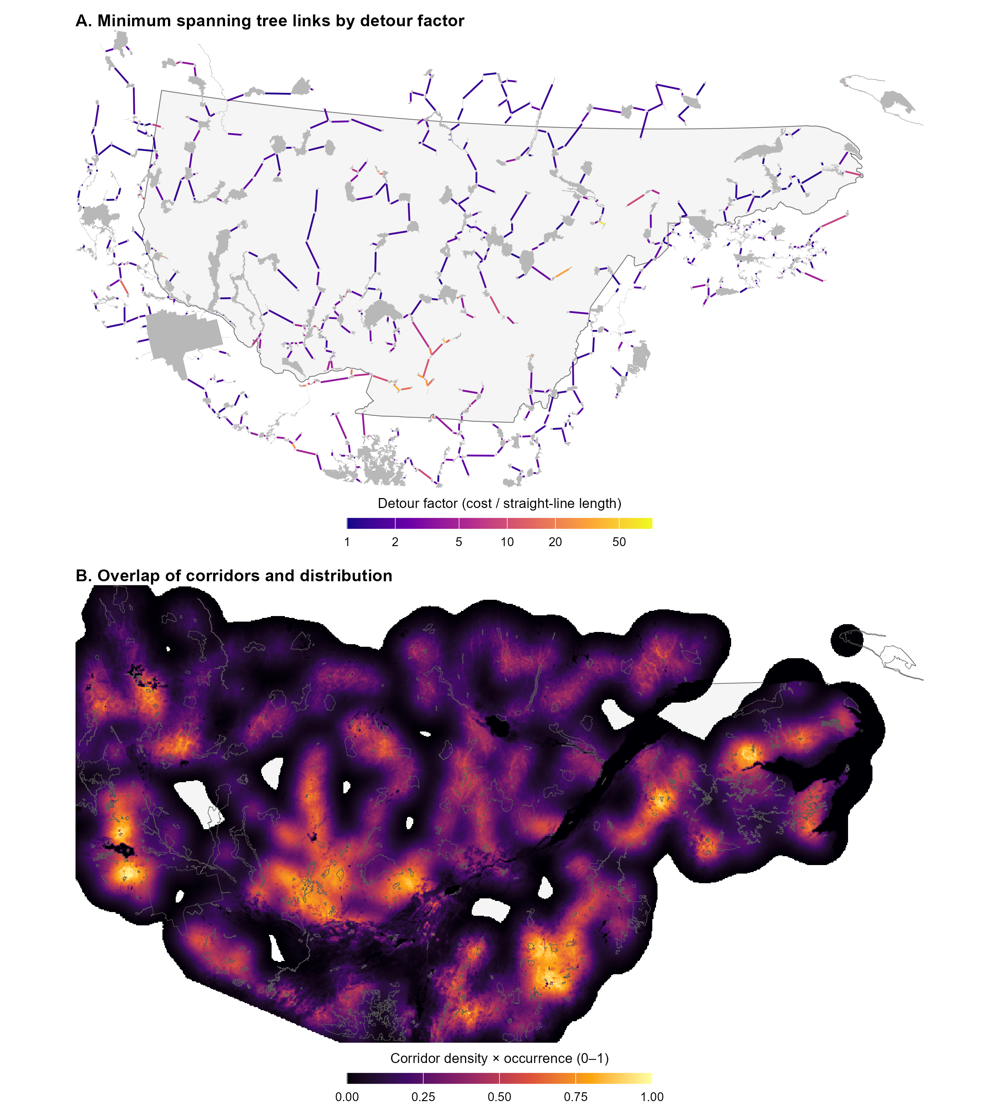
Figure 3. Results for American marten. (A) Minimum spanning tree links coloured by detour factor, the cost distance of a link divided by its straight-line length (1 = optimal habitat throughout; log scale). (B) Overlap of corridor density and predicted probability of occurrence (0–1) across the study area. Grey shapes and outlines are protected areas.
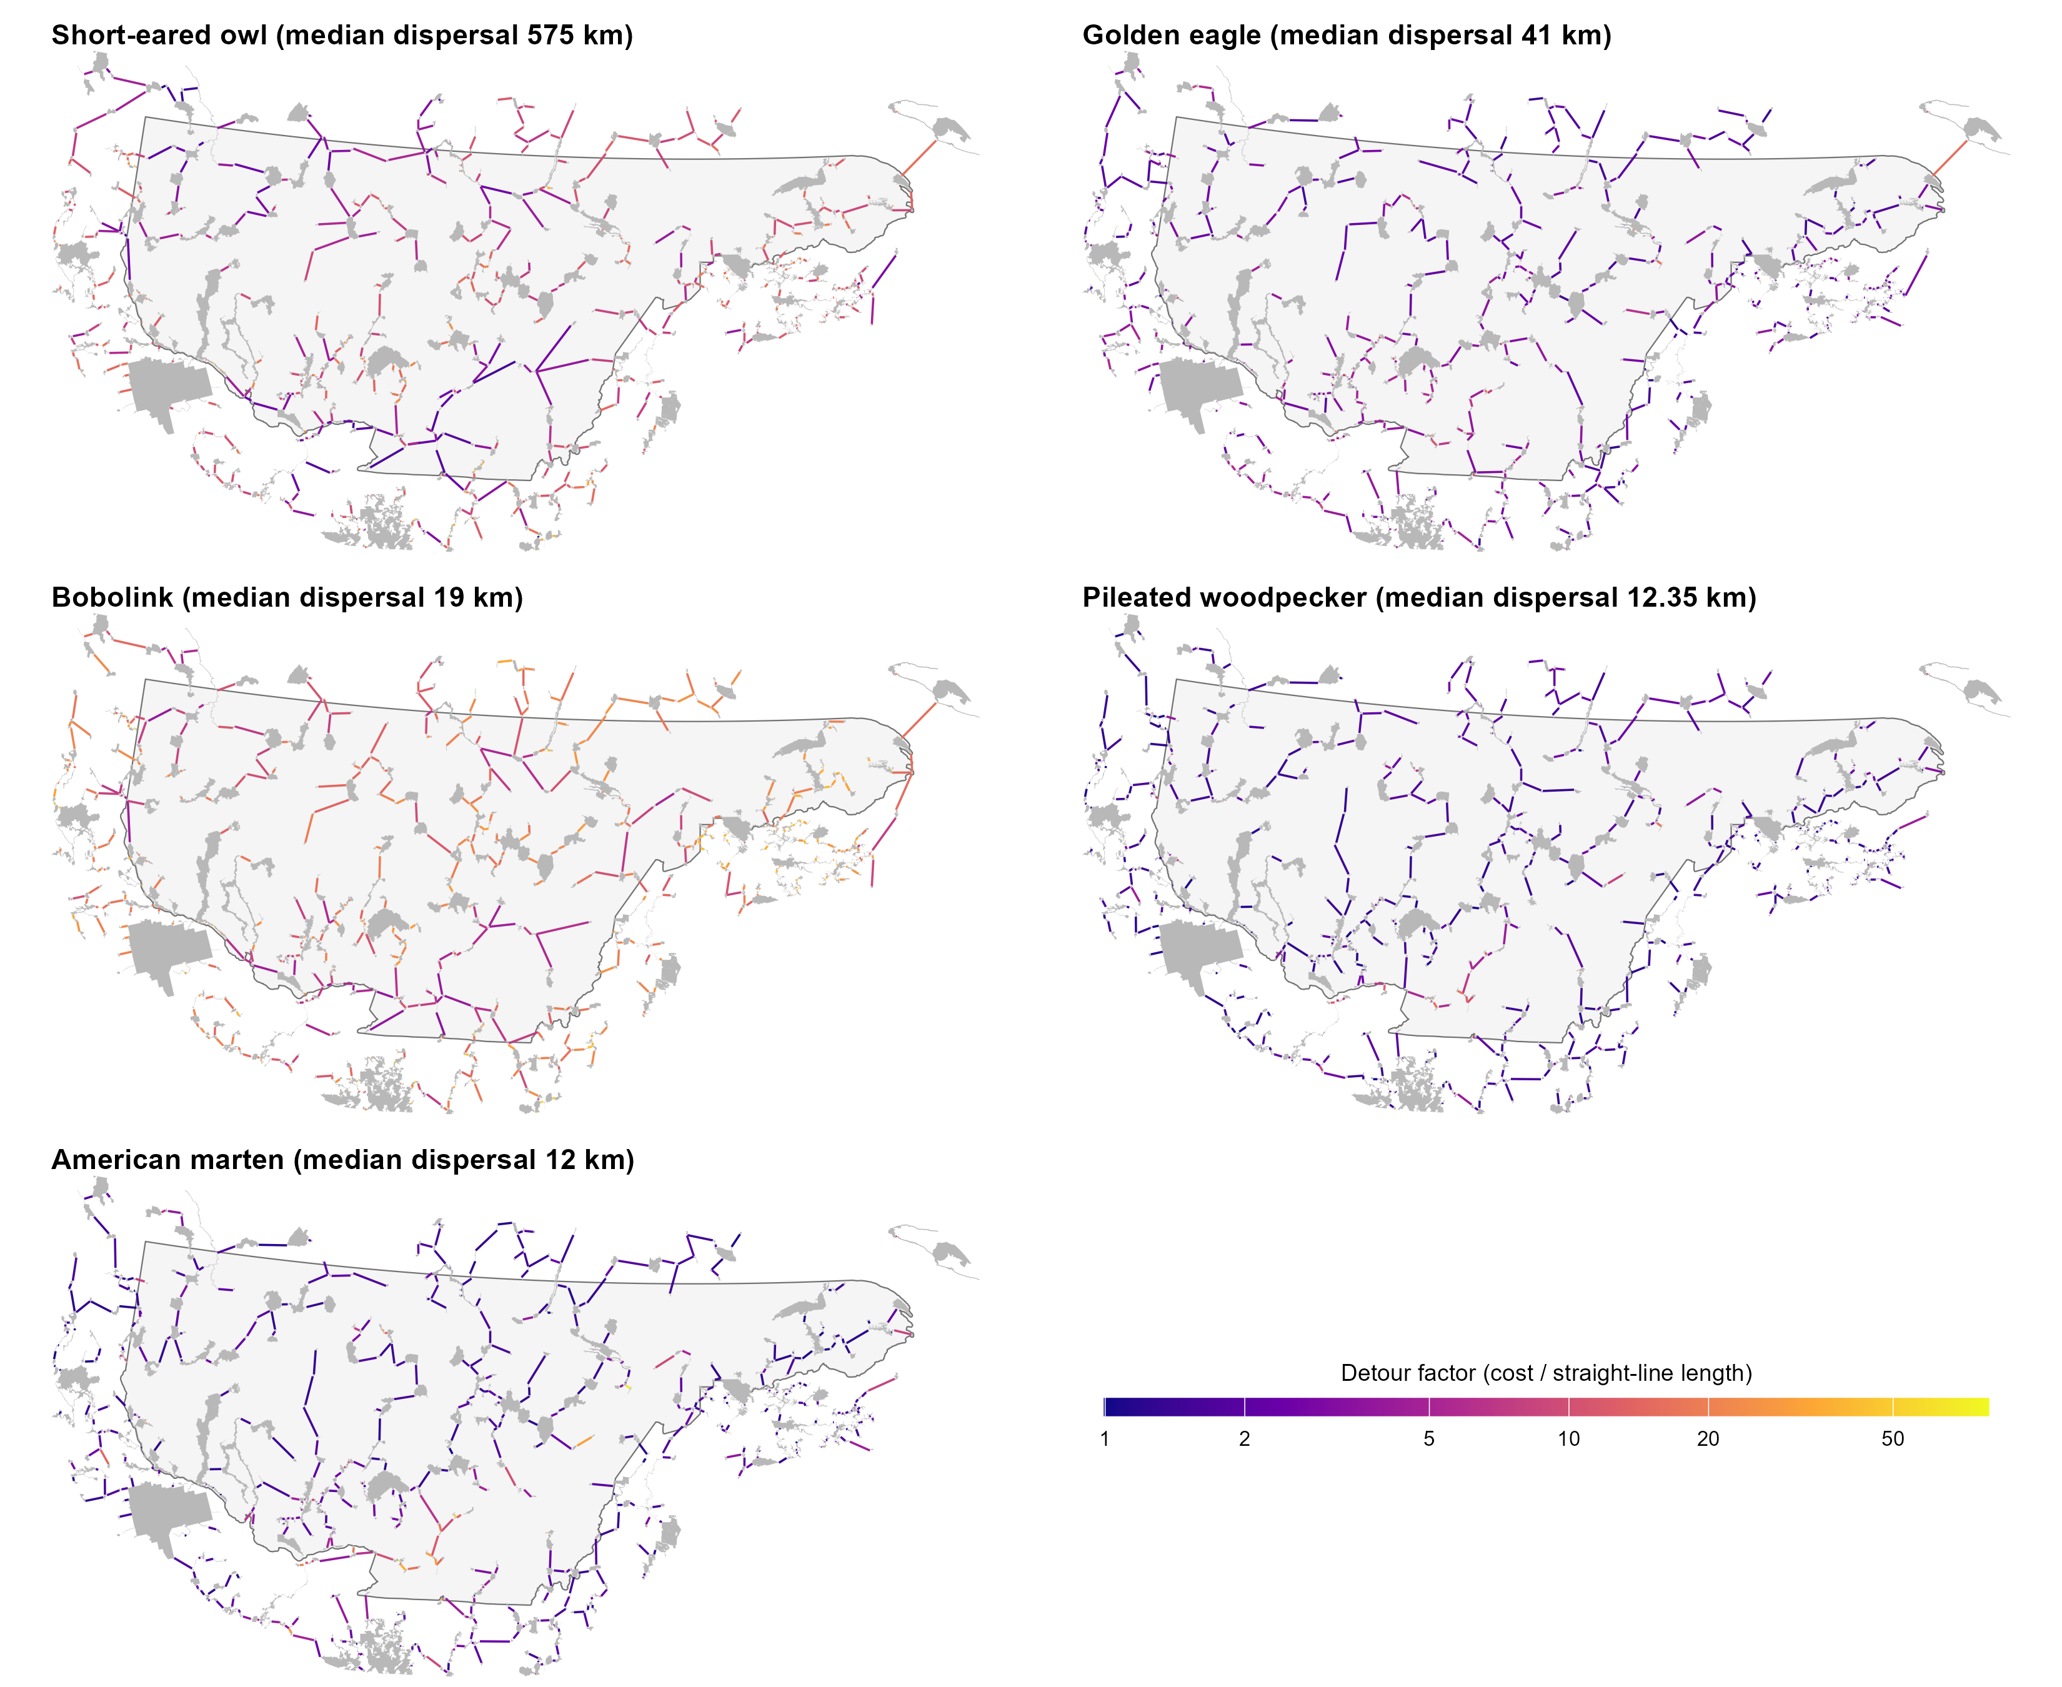
Figure 4. Minimum spanning trees of the five analysed species, with links coloured by detour factor on a common log scale. Species are ordered by decreasing median dispersal distance. Grey shapes are protected areas; the outline is the study area.
Sensitivity to dispersal distance and resistance contrast:
All 40 scenarios were completed (Table 2; results for each scenario are in Supplementary Table S3). The two inputs affected the results in different ways. Changing dispersal distance mainly changed how many protected areas could be linked, and so the structure of the network for the species with the shortest dispersal distances. Halving dispersal distance split the pileated woodpecker and American marten networks into 42 and 45 components, with the largest component holding only 31% of the total protected area (97% at baseline) and split the bobolink network into 10 components (largest 94%). Total tree length fell by 814–1,728 km as links beyond the shorter range dropped out, but 90–96% of the baseline links were retained. Increasing dispersal distance had little effect on the trees (at least 99% of links shared) and, at twice the baseline distance, joined the two components of the pileated woodpecker and American marten networks. The golden eagle and short-eared owl trees were identical in all dispersal scenarios. For golden eagle, even the halved search radius (89 km) exceeds its longest link (72 km). For short-eared owl, candidate links are defined by nearest neighbours rather than by distance.
Because dispersal distance also sets the width of corridor smoothing, the overlap surfaces changed even where the tree did not. Schoener’s D ranged from 0.61–0.62 (pileated woodpecker and American marten at half the dispersal distance) to 0.92, and only 33–74% of the hotspot cells were shared (Jaccard 0.33–0.74). The location of hotspots is therefore the result most sensitive to dispersal distance. The short-eared owl surface did not change because its smoothing width is capped at 100 km in every scenario. The equivalent connected area changed by −14.3 to +10.4 percentage points for short-eared owl and −5.1 to +9.2 for golden eagle, but by less than 4 percentage points for the other three species.
Changing resistance contrast did not change the number of components for any species, because the set of candidate links stays the same. It did change which links were selected: tree link similarity was 0.77–0.93, 87–96% of baseline links were retained, and the largest changes occurred at the extreme values (m = 0.5 and 1.5). Corridor agreement was 0.67–0.88. Total tree length increased with contrast (for example, American marten: −366 km at m = 0.5 to +696 km at m = 1.5). Stronger contrast favours longer link through suitable habitat over shorter links across resistant land cover. Despite these changes in individual links and routes, the overlap surfaces stayed similar to the baseline (Schoener’s D 0.89–0.99; hotspot Jaccard 0.46–0.94), because alternative links and corridors mostly run through the same regions. The equivalent connected area changed by less than 3 percentage points, since link probabilities depend on straight-line distance rather than cost.
Overall, the structure of the networks and the location of corridor hotspots were most sensitive to a shorter dispersal distance, especially for the species with the shortest dispersal distances. The broad pattern of the overlap surfaces was robust to resistance contrast, although 7–23% of individual links and their corridors changed. For American marten, 72% of baseline links (401 of 555) were kept in all eight scenarios. The links that changed were mostly longer (median 18.5 km, compared with 5.3 km for links kept in every scenario), and only 10 were kept in half of the scenarios or fewer (Figure 5A). The overlap surface varied least along the main corridors and most at the edges of the corridor network and in the gaps between corridors (Figure 5B). Maps for all five species are listed under Deliverables, and the effect of each scenario is plotted by species in Supplementary Figures S2–S6.
Table 2. Effect of the sensitivity scenarios on the minimum spanning trees, corridors and distribution overlap. Each cell gives the range across the four levels of the input varied (dispersal distance × 0.5, 0.75, 1.33 and 2; resistance contrast m = 0.5, 0.75, 1.25 and 1.5). For similarity measures, 1 means no change from the baseline.
Species | Input varied | Tree links sharedª | Components (baseline → scenarios) | Change in total tree length (km) | Corridor agreement^{b} | Overlap similarity (Schoener’s D)^{c} | Hotspot overlap^{d} | Change in equivalent connected area (% points)
Short-eared owl | Dispersal distance | 1.00 | 1 → 1 | 0 | 1.00 | 1.00 | 1.00 | −14.3 to +10.4
 | Resistance contrast | 0.78–0.90 | 1 → 1 | −706 to +626 | 0.67–0.88 | 0.98–0.99 | 0.88–0.94 | +0.4 to +1.9
Golden eagle | Dispersal distance | 1.00 | 1 → 1 | 0 | 1.00 | 0.83–0.92 | 0.59–0.72 | −5.1 to +9.2
 | Resistance contrast | 0.86–0.92 | 1 → 1 | −256 to +384 | 0.75–0.86 | 0.93 | 0.74–0.75 | −0.7 to +0.4
Bobolink | Dispersal distance | 0.93–1.00 | 1 → 1–10 | −814 to +58 | 0.87–0.99 | 0.71–0.91 | 0.34–0.65 | −1.1 to +3.3
 | Resistance contrast | 0.80–0.92 | 1 → 1 | −646 to +409 | 0.69–0.88 | 0.89–0.95 | 0.46–0.69 | −0.1 to +2.1
Pileated woodpecker | Dispersal distance | 0.89–1.00 | 2 → 1–42 | −1,526 to +72 | 0.83–1.00 | 0.61–0.90 | 0.33–0.70 | −2.0 to +3.6
 | Resistance contrast | 0.81–0.93 | 2 → 2 | −212 to +367 | 0.73–0.85 | 0.92–0.95 | 0.62–0.76 | −0.2 to 0.0
American marten | Dispersal distance | 0.88–0.99 | 2 → 1–45 | −1,728 to +138 | 0.81–0.99 | 0.62–0.90 | 0.37–0.74 | −1.8 to +3.0
 | Resistance contrast | 0.77–0.87 | 2 → 2 | −366 to +696 | 0.70–0.83 | 0.89–0.93 | 0.57–0.73 | −2.6 to +0.4
ª Jaccard similarity of scenario and baseline tree links (links in both ÷ links in either). ^{b} Share of corridor length within 1 km of the other network’s corridors, averaged over both directions. ^{c} Similarity of the corridor–distribution overlap surfaces on a common 1 km grid. ^{d} Jaccard overlap of the top 10% of cells of the two overlap surfaces.
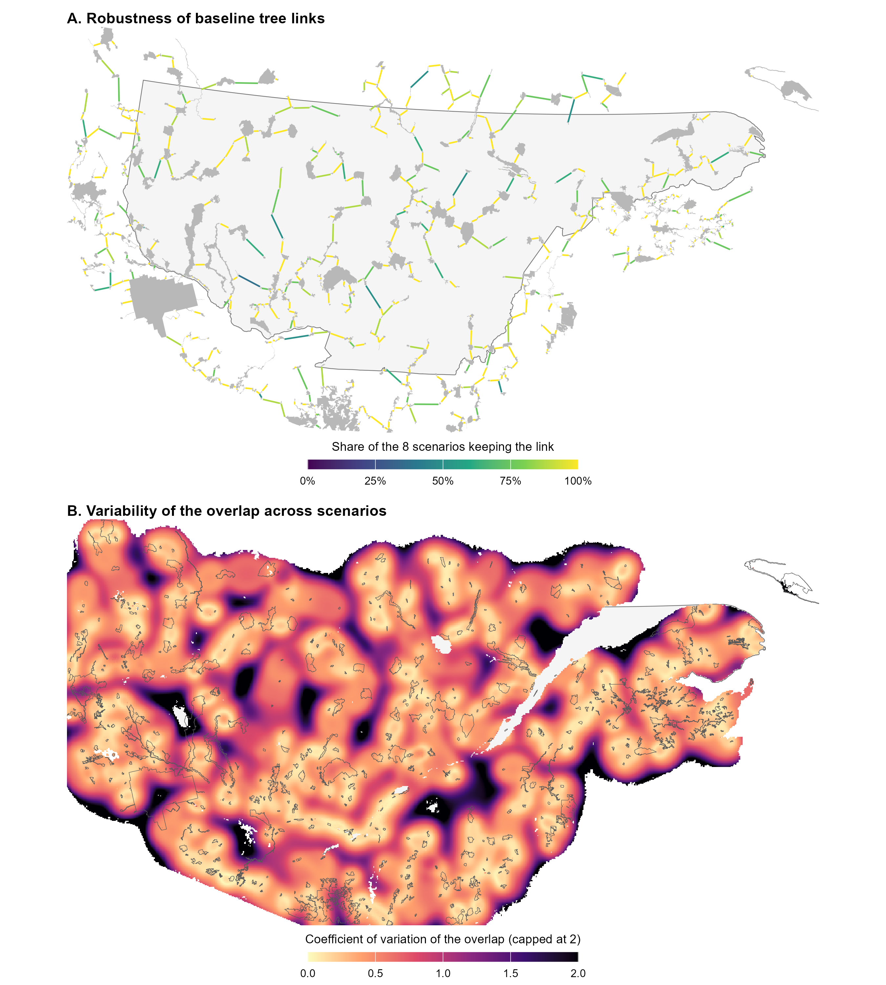
Figure 5. Sensitivity of the American marten results to the eight scenarios (dispersal distance × 0.5, 0.75, 1.33 and 2; resistance contrast m = 0.5, 0.75, 1.25 and 1.5). (A) Baseline tree links coloured by the share of scenarios whose tree contains the same link. (B) Coefficient of variation of the overlap surface across scenarios (standard deviation divided by mean, capped at 2), shown where the mean overlap is at least 1% of its maximum.

References
Adriaensen, F., Chardon, J.P., De Blust, G., Swinnen, E., Villalba, S., Gulinck, H. and Matthysen, E. (2003). The application of ‘least-cost’ modelling as a functional landscape model. Landscape and Urban Planning, 64, 233–247.
Albert, C.H., Rayfield, B., Dumitru, M. and Gonzalez, A. (2017). Applying network theory to prioritize multispecies habitat networks that are robust to climate and land-use change. Conservation Biology, 31, 1383–1396. https://doi.org/10.1111/cobi.12943
Barnett, K. and Belote, R.T. (2021). Modeling an aspirational connected network of protected areas across North America. Ecological Applications, 31, e02387. https://doi.org/10.1002/eap.2387
Beier, P., Majka, D.R. and Newell, S.L. (2009). Uncertainty analysis of least-cost modeling for designing wildlife linkages. Ecological Applications, 19, 2067–2077.
Compton, B.W., McGarigal, K., Cushman, S.A. and Gamble, L.R. (2007). A resistant-kernel model of connectivity for amphibians that breed in vernal pools. Conservation Biology, 21, 788–799.
Csardi, G. and Nepusz, T. (2006). The igraph software package for complex network research. InterJournal, Complex Systems, 1695.
Eckert et al. XXXX WHAT CITATION
Environment and Climate Change Canada (2025). Canadian Protected and Conserved Areas Database. Government of Canada, Gatineau, Quebec.
Hijmans, R.J. (2026). terra: Spatial Data Analysis. R package version 1.9-50.
Pebesma, E. (2018). Simple features for R: standardized support for spatial vector data. The R Journal, 10, 439–446.
Prim, R.C. (1957). Shortest connection networks and some generalizations. Bell System Technical Journal, 36, 1389–1401.
R Core Team (2026). R: A Language and Environment for Statistical Computing, version 4.6.1. R Foundation for Statistical Computing, Vienna, Austria.
Rayfield, B., Fortin, M.-J. and Fall, A. (2010). The sensitivity of least-cost habitat graphs to relative cost surface values. Landscape Ecology, 25, 519–532.
Saura, S., Estreguil, C., Mouton, C. and Rodríguez-Freire, M. (2011). Network analysis to assess landscape connectivity trends: application to European forests (1990–2000). Ecological Indicators, 11, 407–416.
Theobald, D.M., Reed, S.E., Fields, K. and Soulé, M. (2012). Connecting natural landscapes using a landscape permeability model to prioritize conservation activities in the United States. Conservation Letters, 5, 123–133.
U.S. Geological Survey Gap Analysis Project (2024). Protected Areas Database of the United States (PAD-US) 4.1. U.S. Geological Survey data release. https://doi.org/10.5066/P96WBCHS
van Etten, J. (2017). R package gdistance: distances and routes on geographical grids. Journal of Statistical Software, 76(13), 1–21.
Warren, D.L., Glor, R.E. and Turelli, M. (2008). Environmental niche equivalency versus conservatism: quantitative approaches to niche evolution. Evolution, 62, 2868–2883.
Supplementary information
S1. Focal species
Species traits are maintained in the “top10” sheet of specieslist.xlsx, with sources in its literature review sheets. Search radius and smoothing standard deviation follow from the median dispersal distance (Supplementary Sections S2 and S4). Four-letter codes are used as file-name prefixes for every output.
Table S1. Focal species, dispersal parameters and analysis status.
Code | Common name | Scientific name | Dispersal mode | Median dispersal (km) | Search radius (km) | Smoothing standard deviation (km) | Distribution model | Status
ASFL | Short-eared owl | Asio flammeus | Flying | 575 | 2,485 | 144.3ª | Yes | Analysed
AQCH | Golden eagle | Aquila chrysaetos | Flying | 41 | 177 | 59.2 | Yes | Analysed
DOOR | Bobolink | Dolichonyx oryzivorus | Flying | 19 | 82 | 27.4 | Yes | Analysed
DRPI | Pileated woodpecker | Dryocopus pileatus | Flying | 12.35 | 53 | 17.8 | Yes | Analysed
MAAM | American marten | Martes americana | Fossorial | 12 | 52 | 17.3 | Yes | Analysed
LYCA | Canada lynx | Lynx canadensis | Terrestrial | 100 | 432 | 144.3 | Yes | Pending
CSCA | Beaver | Castor canadensis | Aquatic | 9.075 | 39 | 13.1 | Yes | Pending
GLIN | Wood turtle | Glyptemys insculpta | Aquatic | 0.219 | 0.95 | 0.32 | No | Pending
PLCI | Eastern red-backed salamander | Plethodon cinereus | Fossorial | 0.09 | 0.39 | 0.13 | Yes | Pending
CLGA | Southern red-backed vole | Clethrionomys gapperi | Fossorial | 0.03 | 0.13 | 0.06^{b} | Yes | Pending
ª Median dispersal capped at 100 km for smoothing. ^{b} Floored at two grid cells (60 m).
S2. Protected areas and candidate links
Protected-area sources were the Quebec register of protected areas and the Canadian Protected and Conserved Areas Database (terrestrial areas only; Environment and Climate Change Canada 2025), Ontario federal protected areas and regulated provincial parks, New Brunswick wildlife refuges, Nature Legacy protected areas and protected natural areas, and the Protected Areas Database of the United States 4.1 for New York, Vermont, New Hampshire and Maine (U.S. Geological Survey Gap Analysis Project 2024). Nineteen large aquatic protected areas were removed by identifier. Overlapping polygons were dissolved, and polygons within 50 m of each other were joined by buffering outward and back by 50 m. A 10 km² subset was also produced, but all analyses so far use the 5 km² set. Boundaries were simplified with a 30 m tolerance (topology preserved). All layers use the NAD83 / Quebec Lambert projection (EPSG:32198).
The kernel parameter is α = ln 2 / D₅₀, and the search radius is −ln(0.05) / α ≈ 4.32 × D₅₀. Candidate pairs were first screened with a spatial index (sf::st_is_within_distance) and exact edge-to-edge distances were then computed only for the retained pairs. Species with D₅₀ > 100 km (currently the short-eared owl only) are sparsified to each patch’s 20 nearest partners plus the edges of the straight-line minimum spanning tree. The same dispersal cutoff is re-applied, on straight-line distance, before the tree is built.
S3. Resistance scoring
Ranks are converted to resistance as 2^{rank}. Suitability tiers map to ranks as follows: highly suitable 0, suitable 2, poorly suitable 3, unsuitable 5. Fixed ranks common to all species are urban 6, major roads 6, railways 6, minor roads 5, forestry roads class A 5, and forestry roads classes B and C 4. Flying species receive −1 on all road and railway ranks. Water starts at rank 5 and is adjusted by dispersal mode: −1 for flying and aquatic species, +1 for fossorial species, unchanged for terrestrial species (floored at 0).
Forest cells take the species’ forest-type rank (coniferous, deciduous or mixed) plus an age penalty. The penalty is the number of ordinal steps (young → mature → old) between the cell’s age class and the nearest age class the species prefers (0–3). The two intermediate age classes count as mature. Uneven-aged stands score 0 for species preferring young or old forest, and 1 for species preferring mature forest only. For forest types the species rates unsuitable, the age penalty is capped at +1, so unsuitable forest reaches at most rank 6, the same as urban areas. Forest cells with missing type or age data use the rounded mean of the species’ three forest-type ranks. Wetlands are split into open and forested classes, each rated separately per species.
Table S2. Resistance values (2^{rank}) by land-cover class for the five analysed species. Forest values exclude the age penalty, which multiplies resistance by 2 per age-class step.
Land-cover class | Short-eared owl | Golden eagle | Bobolink | Pileated woodpecker | American marten
Agriculture | 1 | 4 | 4 | 32 | 32
Wetland, open | 1 | 8 | 4 | 32 | 32
Wetland, forested | 8 | 8 | 32 | 1 | 4
Grassland | 1 | 1 | 1 | 32 | 32
Barren and shrubland | 1 | 1 | 8 | 32 | 32
Coniferous forest | 8 | 1 | 32 | 4 | 1
Deciduous forest | 32 | 4 | 32 | 1 | 4
Mixed forest | 32 | 4 | 32 | 1 | 1
Forest, type or age missing | 16 | 2 | 32 | 2 | 2
Water | 16 | 16 | 16 | 16 | 64
Urban | 64 | 64 | 64 | 64 | 64
Major roads and railways | 32 | 32 | 32 | 32 | 64
Minor roads, forestry roads A | 16 | 16 | 16 | 16 | 32
Forestry roads B and C | 8 | 8 | 8 | 8 | 16
S4. Cost distance, corridors and overlap
Cost distance was computed once per origin patch with terra::costDist on the resistance raster cropped to the origin and its candidate destinations, buffered by the larger of 25% of the longest pair distance or 1 km. Every cell of the origin polygon is a zero-cost source, and each destination’s cost is the minimum accumulated cost over its own polygon. If a destination was unreachable, the origin was retried once with a doubled buffer. Pairs still without a cost were dropped. Tree edges are also saved as straight boundary-to-boundary lines for mapping.
Least-cost paths were traced with gdistance (conductance = 1 / mean resistance of neighbouring cells) between the geometrically nearest points of the two patch boundaries. The resistance raster was cropped per link to a buffer of 25% of the link length (between 1 and 5 km), with one retry at double the buffer. For corridor density, each path was rasterized and smoothed per link on a species-specific grid (resolution ≈ smoothing standard deviation / 10, a multiple of 30 m and at most 1 km), with the crop padded by three standard deviations, and the links were summed. A combined multi-species density map was built on a common 1 km grid, with each species normalized to its own maximum before summing so that no species dominates. Distribution models (Eckert et al. 2023) are continent-wide; only the current-climate layer was used. It was cropped to the modelling extent plus 10 km, reprojected at its native ~1 km resolution, and missing values were set to 0. In the overlap step, the lowest 10% of corridor density values were removed, corridor density and the distribution model were each rescaled to 0–1, and the two were multiplied.
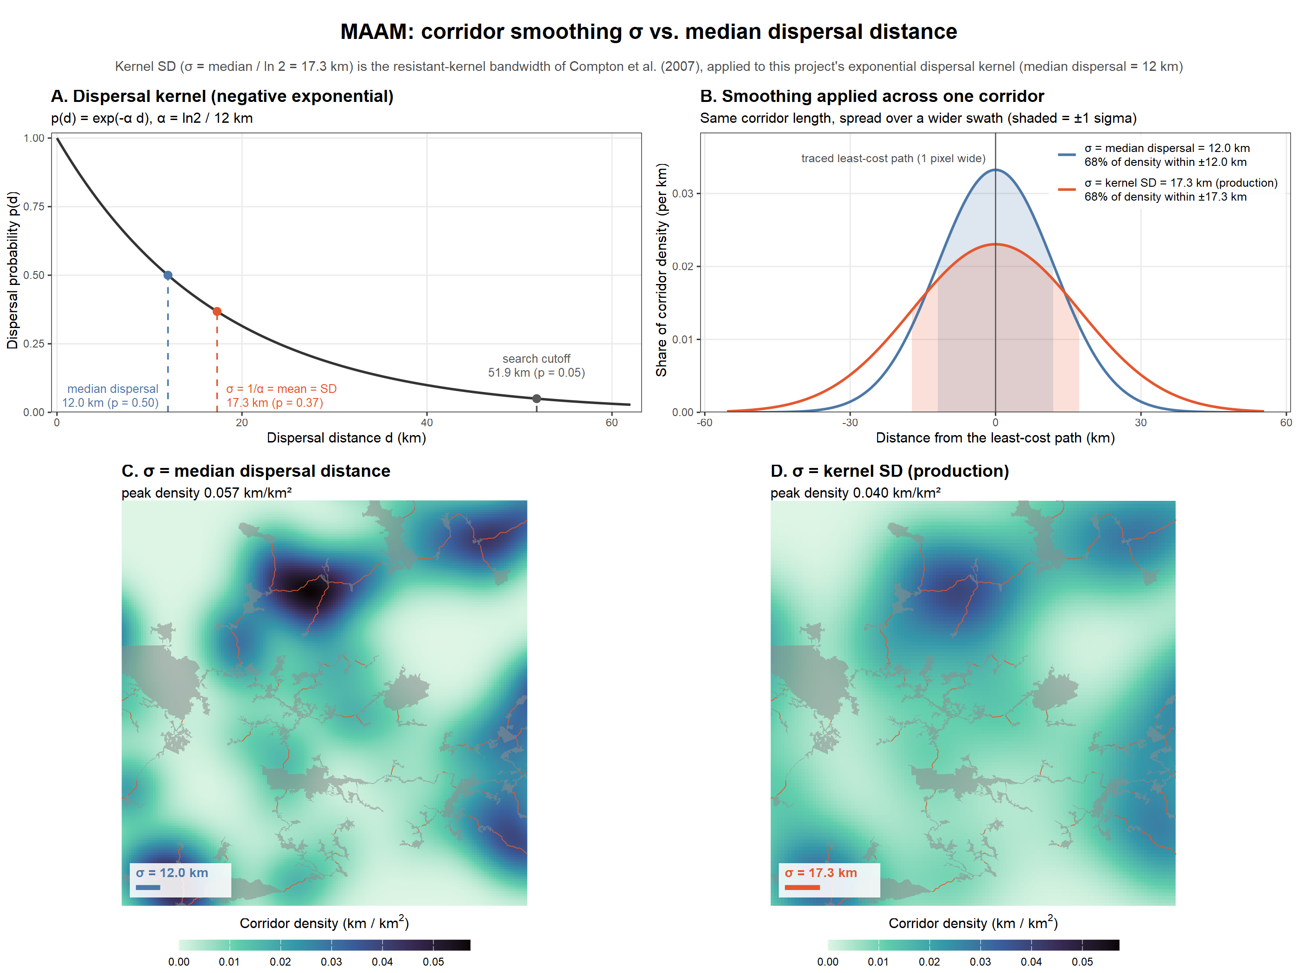
Figure S1. Choice of the corridor smoothing width, shown for American marten. (A) Dispersal kernel with the median dispersal distance, the kernel’s mean (= standard deviation, used as the smoothing width) and the search radius marked. (B) Cross-section of the Gaussian smoothing applied to one corridor with each width. (C–D) The species’ traced corridors in its densest 200 km window, smoothed with the median dispersal distance (C) and with the kernel standard deviation used in the analysis (D), on a common colour scale. Labels use σ for the smoothing standard deviation.
S5. Sensitivity analysis design
Each scenario changes one input from the baseline. In dispersal scenarios, median dispersal distance is multiplied by 0.5, 0.75, 1.33 or 2, which moves both the dispersal cutoff and the smoothing standard deviation. The dispersal probability cutoff needs no scenarios of its own, because it moves the same search radius (a cutoff of 0.01 is equivalent to dispersal × 1.54, and 0.10 to × 0.77). In contrast scenarios, resistance = 2^{m × rank} with m = 0.5, 0.75, 1.25 or 1.5. Since ranks are integers, the scenario raster is exactly the baseline raster raised to the power m. The ranks and suitability ratings themselves were not varied. Dispersal scenarios reuse the baseline resistance raster, cost distances and corridors: a shorter cutoff drops pairs, a longer one costs only the additional pairs, and only new tree links are traced. Contrast scenarios reuse the baseline candidate pairs and recompute cost distances, the tree, corridors, density and overlap. Each scenario is run through the same functions as the baseline analysis.
Scenarios are compared with the baseline on the tree, corridor and surface levels. For the tree, the measures are link Jaccard similarity and the share of baseline links retained. For corridors, the measure is the share of dissolved corridor length within 1 km of the other network’s corridors, averaged over both directions (Beier et al. 2009). For the 1 km overlap surfaces, the measures are the cell-wise Spearman correlation, Schoener’s D (Warren et al. 2008) and the Jaccard overlap of the top 10% of cells. Cell-wise Spearman correlations ranged from 0.71 to 1.00 and are not reported further. Robustness maps report two things: for each baseline link, the share of scenarios that keep it, and for each cell, the mean, standard deviation and coefficient of variation of the overlap surface across scenarios. The 40 scenarios took about 35 hours of computing time in total, mostly cost distance for contrast scenarios and for the longest dispersal distances.
Table S3. Results of each sensitivity scenario. Similarity measures are relative to the baseline (1 = identical); see Table 2 for definitions.
Species | Scenario | Components | Total tree length (km) | Tree links shared | Baseline links kept (%) | Corridor agreement | Schoener’s D | Hotspot overlap | Equivalent connected area (% of protected area)
Short-eared owl | Baseline | 1 | 6,655 | 1 | 100 | 1 | 1 | 1 | 76.0
 | Dispersal ×0.5 | 1 | 6,655 | 1.00 | 100 | 1.00 | 1.00 | 1.00 | 61.7
 | Dispersal ×0.75 | 1 | 6,655 | 1.00 | 100 | 1.00 | 1.00 | 1.00 | 70.5
 | Dispersal ×1.33 | 1 | 6,655 | 1.00 | 100 | 1.00 | 1.00 | 1.00 | 80.9
 | Dispersal ×2 | 1 | 6,655 | 1.00 | 100 | 1.00 | 1.00 | 1.00 | 86.4
 | Contrast m = 0.5 | 1 | 5,949 | 0.78 | 88 | 0.67 | 0.98 | 0.88 | 77.3
 | Contrast m = 0.75 | 1 | 6,253 | 0.88 | 93 | 0.81 | 0.98 | 0.91 | 78.0
 | Contrast m = 1.25 | 1 | 6,993 | 0.90 | 95 | 0.88 | 0.99 | 0.94 | 76.4
 | Contrast m = 1.5 | 1 | 7,281 | 0.83 | 91 | 0.79 | 0.98 | 0.92 | 77.0
Golden eagle | Baseline | 1 | 6,034 | 1 | 100 | 1 | 1 | 1 | 33.5
 | Dispersal ×0.5 | 1 | 6,034 | 1.00 | 100 | 1.00 | 0.83 | 0.59 | 28.4
 | Dispersal ×0.75 | 1 | 6,034 | 1.00 | 100 | 1.00 | 0.91 | 0.72 | 31.0
 | Dispersal ×1.33 | 1 | 6,034 | 1.00 | 100 | 1.00 | 0.92 | 0.69 | 36.7
 | Dispersal ×2 | 1 | 6,034 | 1.00 | 100 | 1.00 | 0.88 | 0.62 | 42.7
 | Contrast m = 0.5 | 1 | 5,777 | 0.86 | 92 | 0.75 | 0.93 | 0.75 | 33.9
 | Contrast m = 0.75 | 1 | 5,901 | 0.92 | 96 | 0.86 | 0.93 | 0.75 | 33.6
 | Contrast m = 1.25 | 1 | 6,215 | 0.90 | 95 | 0.86 | 0.93 | 0.74 | 33.0
 | Contrast m = 1.5 | 1 | 6,418 | 0.86 | 92 | 0.79 | 0.93 | 0.74 | 32.7
Bobolink | Baseline | 1 | 6,537 | 1 | 100 | 1 | 1 | 1 | 25.9
 | Dispersal ×0.5 | 10 | 5,722 | 0.93 | 96 | 0.87 | 0.71 | 0.34 | 24.8
 | Dispersal ×0.75 | 2 | 6,441 | 0.99 | 100 | 0.99 | 0.90 | 0.65 | 25.1
 | Dispersal ×1.33 | 1 | 6,594 | 1.00 | 100 | 0.99 | 0.91 | 0.63 | 26.9
 | Dispersal ×2 | 1 | 6,594 | 1.00 | 100 | 0.99 | 0.84 | 0.46 | 29.1
 | Contrast m = 0.5 | 1 | 5,890 | 0.80 | 89 | 0.69 | 0.89 | 0.46 | 28.0
 | Contrast m = 0.75 | 1 | 6,088 | 0.88 | 93 | 0.81 | 0.92 | 0.54 | 27.1
 | Contrast m = 1.25 | 1 | 6,778 | 0.92 | 96 | 0.88 | 0.95 | 0.69 | 25.9
 | Contrast m = 1.5 | 1 | 6,946 | 0.88 | 93 | 0.81 | 0.93 | 0.65 | 25.8
Pileated woodpecker | Baseline | 2 | 5,956 | 1 | 100 | 1 | 1 | 1 | 26.2
 | Dispersal ×0.5 | 42 | 4,430 | 0.89 | 91 | 0.83 | 0.61 | 0.33 | 24.2
 | Dispersal ×0.75 | 11 | 5,491 | 0.97 | 97 | 0.93 | 0.83 | 0.58 | 25.2
 | Dispersal ×1.33 | 2 | 5,956 | 1.00 | 100 | 1.00 | 0.90 | 0.70 | 27.4
 | Dispersal ×2 | 1 | 6,028 | 1.00 | 100 | 1.00 | 0.79 | 0.42 | 29.8
 | Contrast m = 0.5 | 2 | 5,744 | 0.86 | 93 | 0.73 | 0.93 | 0.69 | 26.2
 | Contrast m = 0.75 | 2 | 5,812 | 0.93 | 96 | 0.85 | 0.94 | 0.76 | 26.2
 | Contrast m = 1.25 | 2 | 6,140 | 0.90 | 95 | 0.84 | 0.95 | 0.74 | 26.2
 | Contrast m = 1.5 | 2 | 6,323 | 0.81 | 90 | 0.73 | 0.92 | 0.62 | 26.0
American marten | Baseline | 2 | 6,140 | 1 | 100 | 1 | 1 | 1 | 25.9
 | Dispersal ×0.5 | 45 | 4,413 | 0.88 | 90 | 0.81 | 0.62 | 0.37 | 24.1
 | Dispersal ×0.75 | 11 | 5,592 | 0.95 | 97 | 0.91 | 0.84 | 0.64 | 25.1
 | Dispersal ×1.33 | 2 | 6,207 | 0.99 | 100 | 0.99 | 0.90 | 0.74 | 27.0
 | Dispersal ×2 | 1 | 6,278 | 0.99 | 100 | 0.98 | 0.80 | 0.50 | 28.9
 | Contrast m = 0.5 | 2 | 5,774 | 0.82 | 90 | 0.72 | 0.91 | 0.63 | 26.3
 | Contrast m = 0.75 | 2 | 5,851 | 0.87 | 93 | 0.83 | 0.93 | 0.70 | 26.2
 | Contrast m = 1.25 | 2 | 6,460 | 0.86 | 92 | 0.82 | 0.93 | 0.73 | 23.4
 | Contrast m = 1.5 | 2 | 6,837 | 0.77 | 87 | 0.70 | 0.89 | 0.57 | 23.3
S6. Outstanding decisions
(1) The dispersal cutoff for tree links is applied to straight-line edge-to-edge distance rather than cost distance. (2) Networks that split into components (pileated woodpecker, American marten) could be joined by adding the cheapest link between components, flagged as exceeding the dispersal kernel. (3) Canada lynx (D₅₀ = 100 km) falls exactly at the sparsification threshold and is therefore not sparsified, giving a search radius of ~432 km; this threshold should be confirmed before lynx is run. (4) The open and forested wetland ratings for each species were initially copied from a single wetland rating and await species-by-species review. (5) Wood turtle has no distribution model and will receive corridor density only. (6) The resistance contrast scenarios showed that the choice of a doubling scale changes 7–23% of tree links; the suitability ratings of individual habitat types were not tested and remain a source of uncertainty.
S7. Sensitivity results by species
Figures S2–S6 show the effect of each scenario on four results, for each analysed species. The panels give the share of tree links that changed (1 − Jaccard similarity), the share of corridor length that moved more than 1 km from the baseline corridors, the change in the corridor–distribution overlap surface (1 − Schoener’s D) and the change in the number of network components. Each panel is plotted against the baseline (0 = no change). Rows are the eight scenarios, with the dispersal scenarios above the dashed line and the contrast scenarios below it; red points are levels above the baseline value and blue points are levels below it. Figure labels use the abbreviations MST (minimum spanning tree) and SDM (species distribution model).
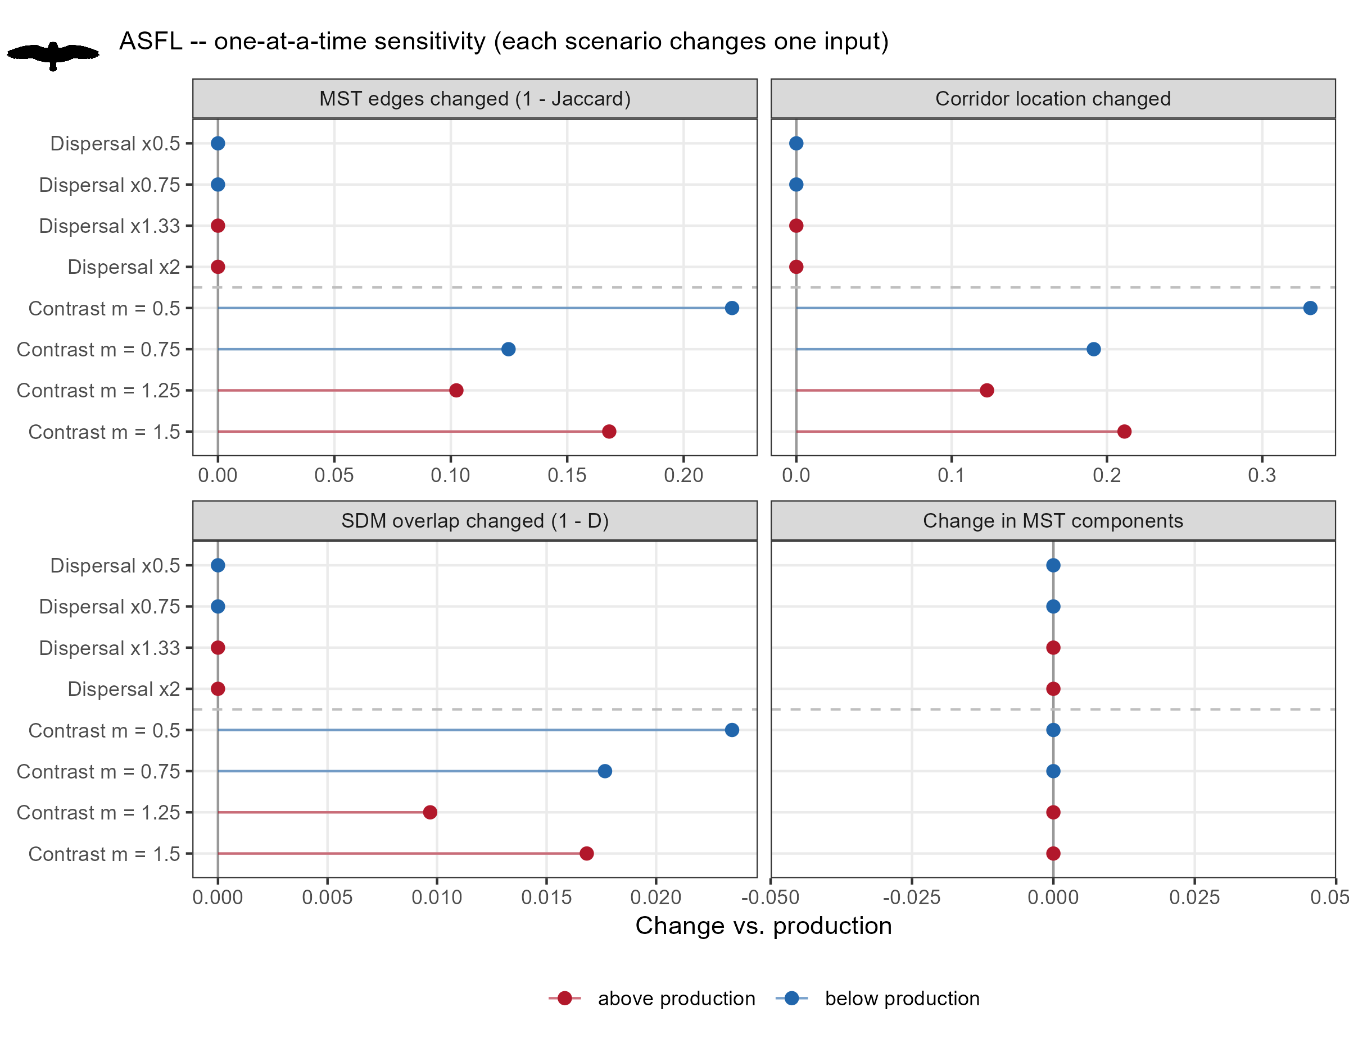
Figure S2. Effect of each sensitivity scenario on the short-eared owl results (see Section S7 for the panels).
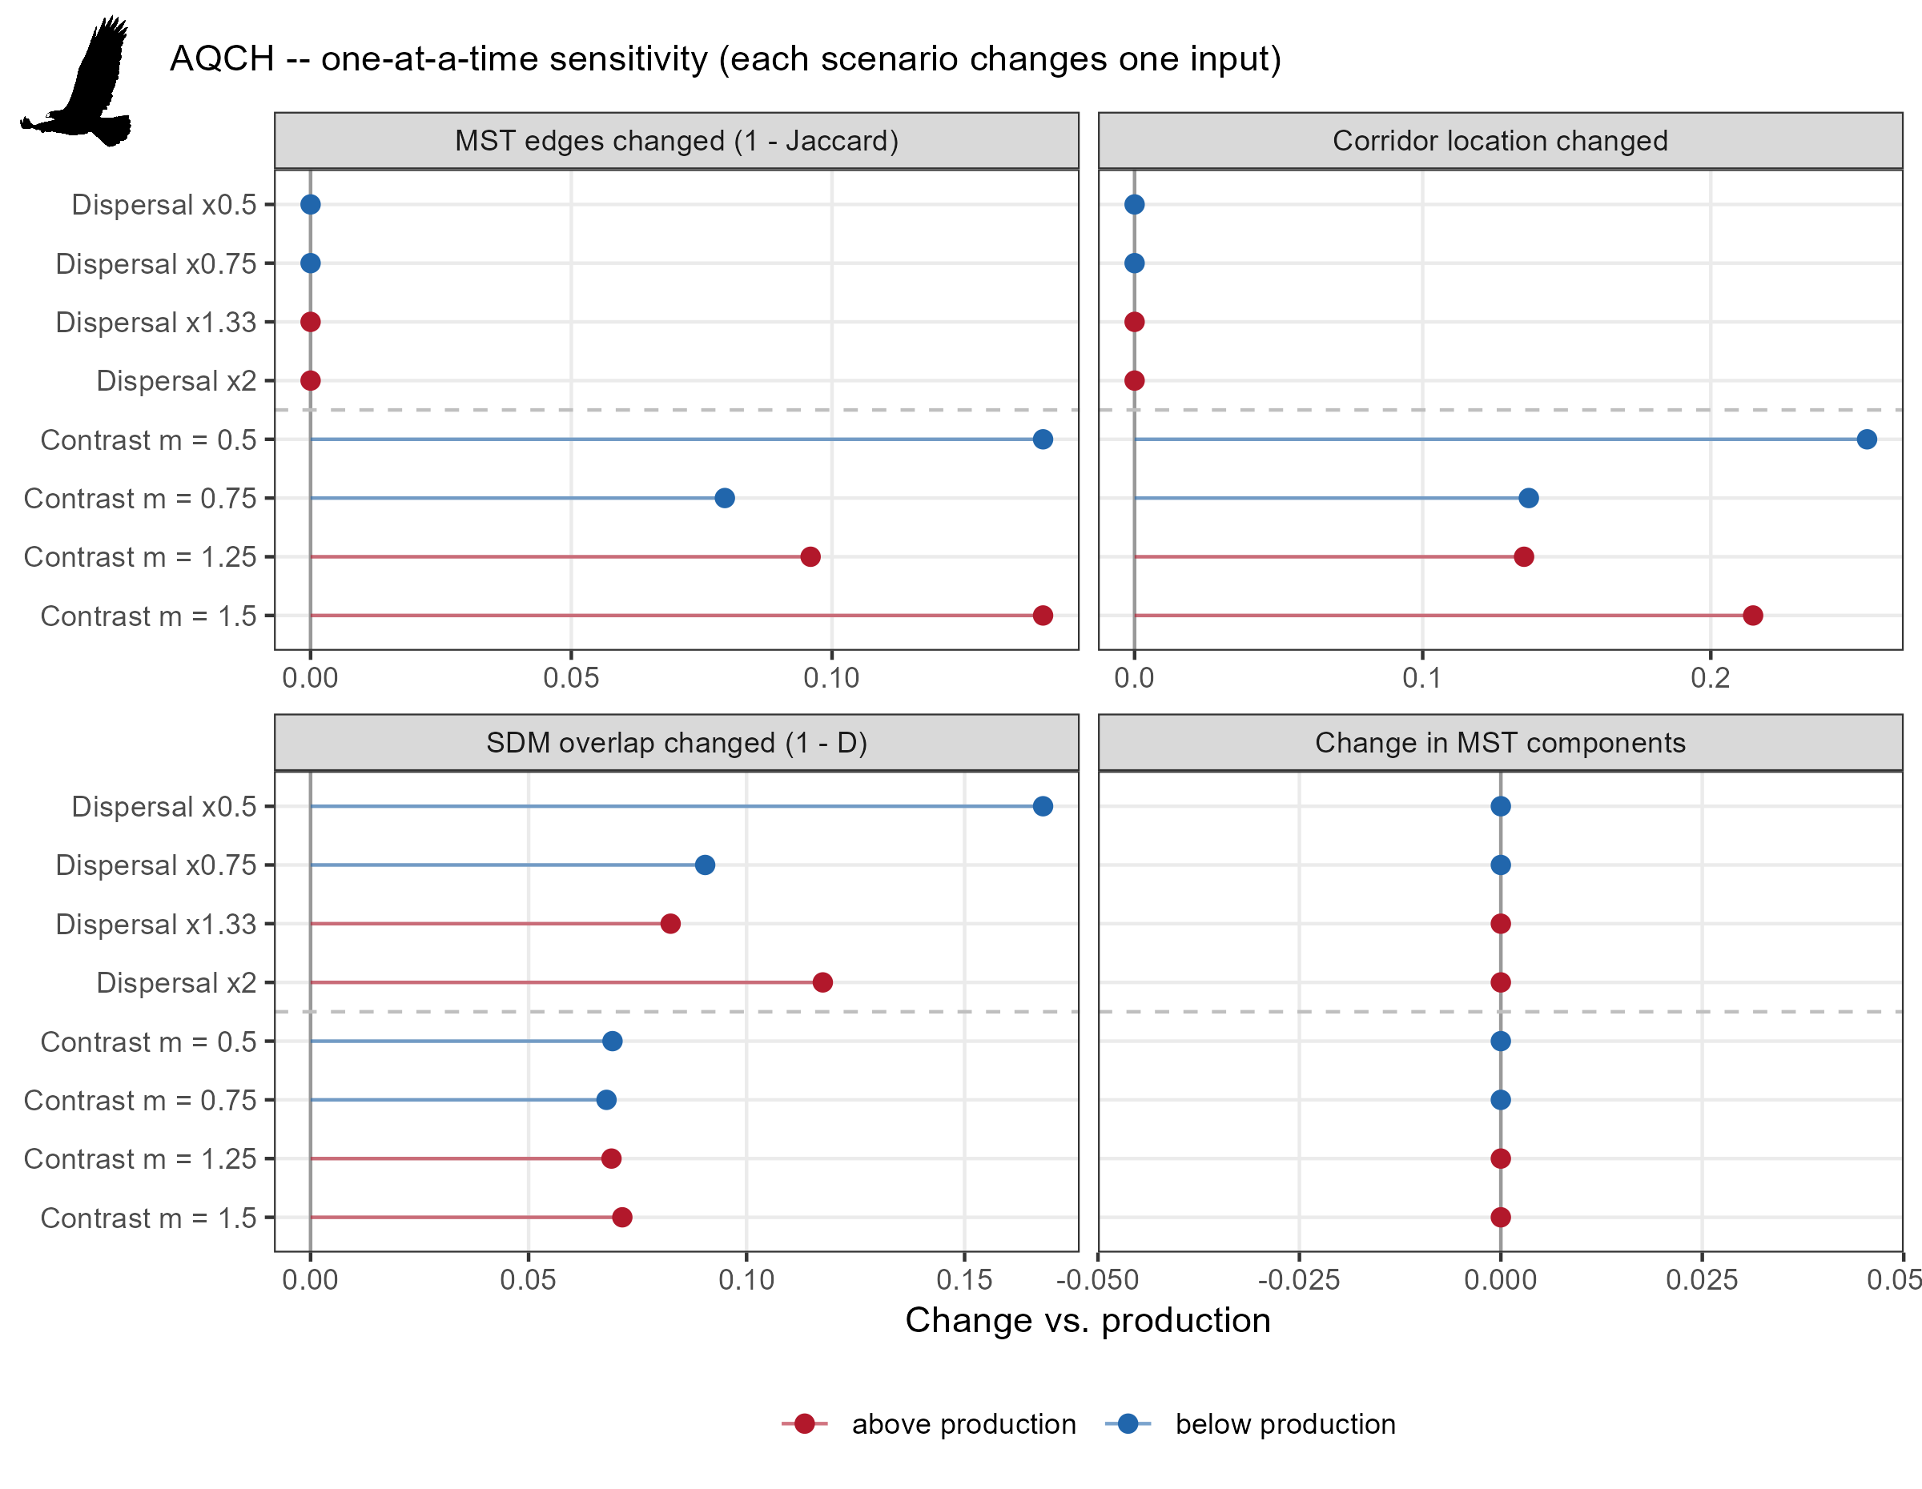
Figure S3. Effect of each sensitivity scenario on the golden eagle results (see Section S7 for the panels).
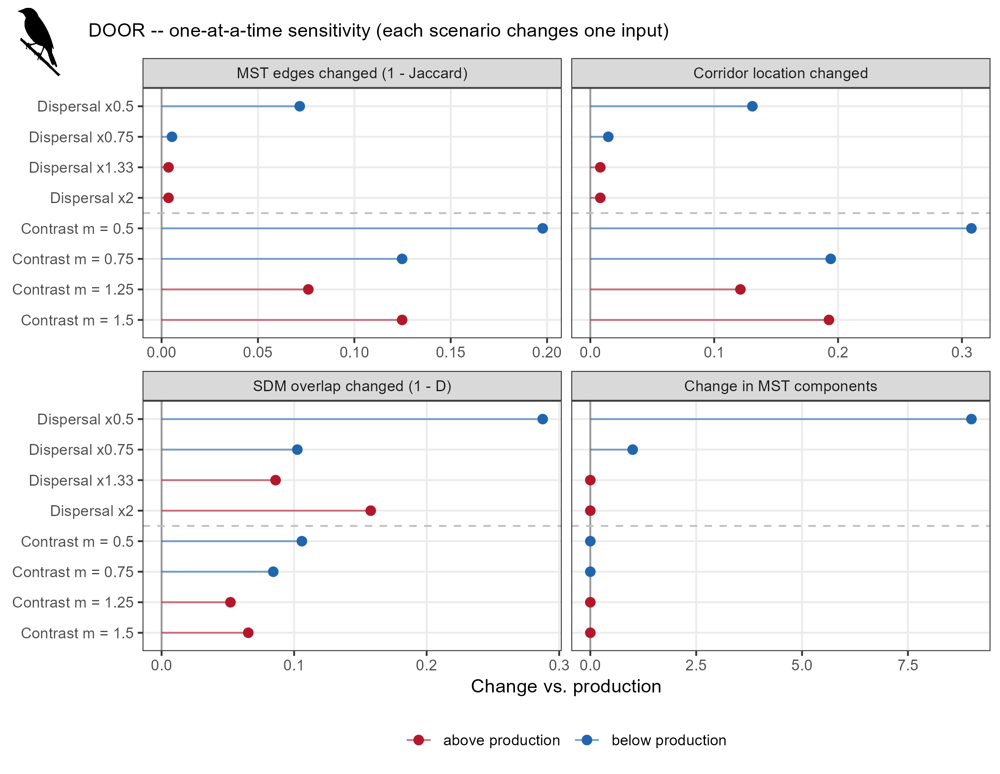
Figure S4. Effect of each sensitivity scenario on the bobolink results (see Section S7 for the panels).
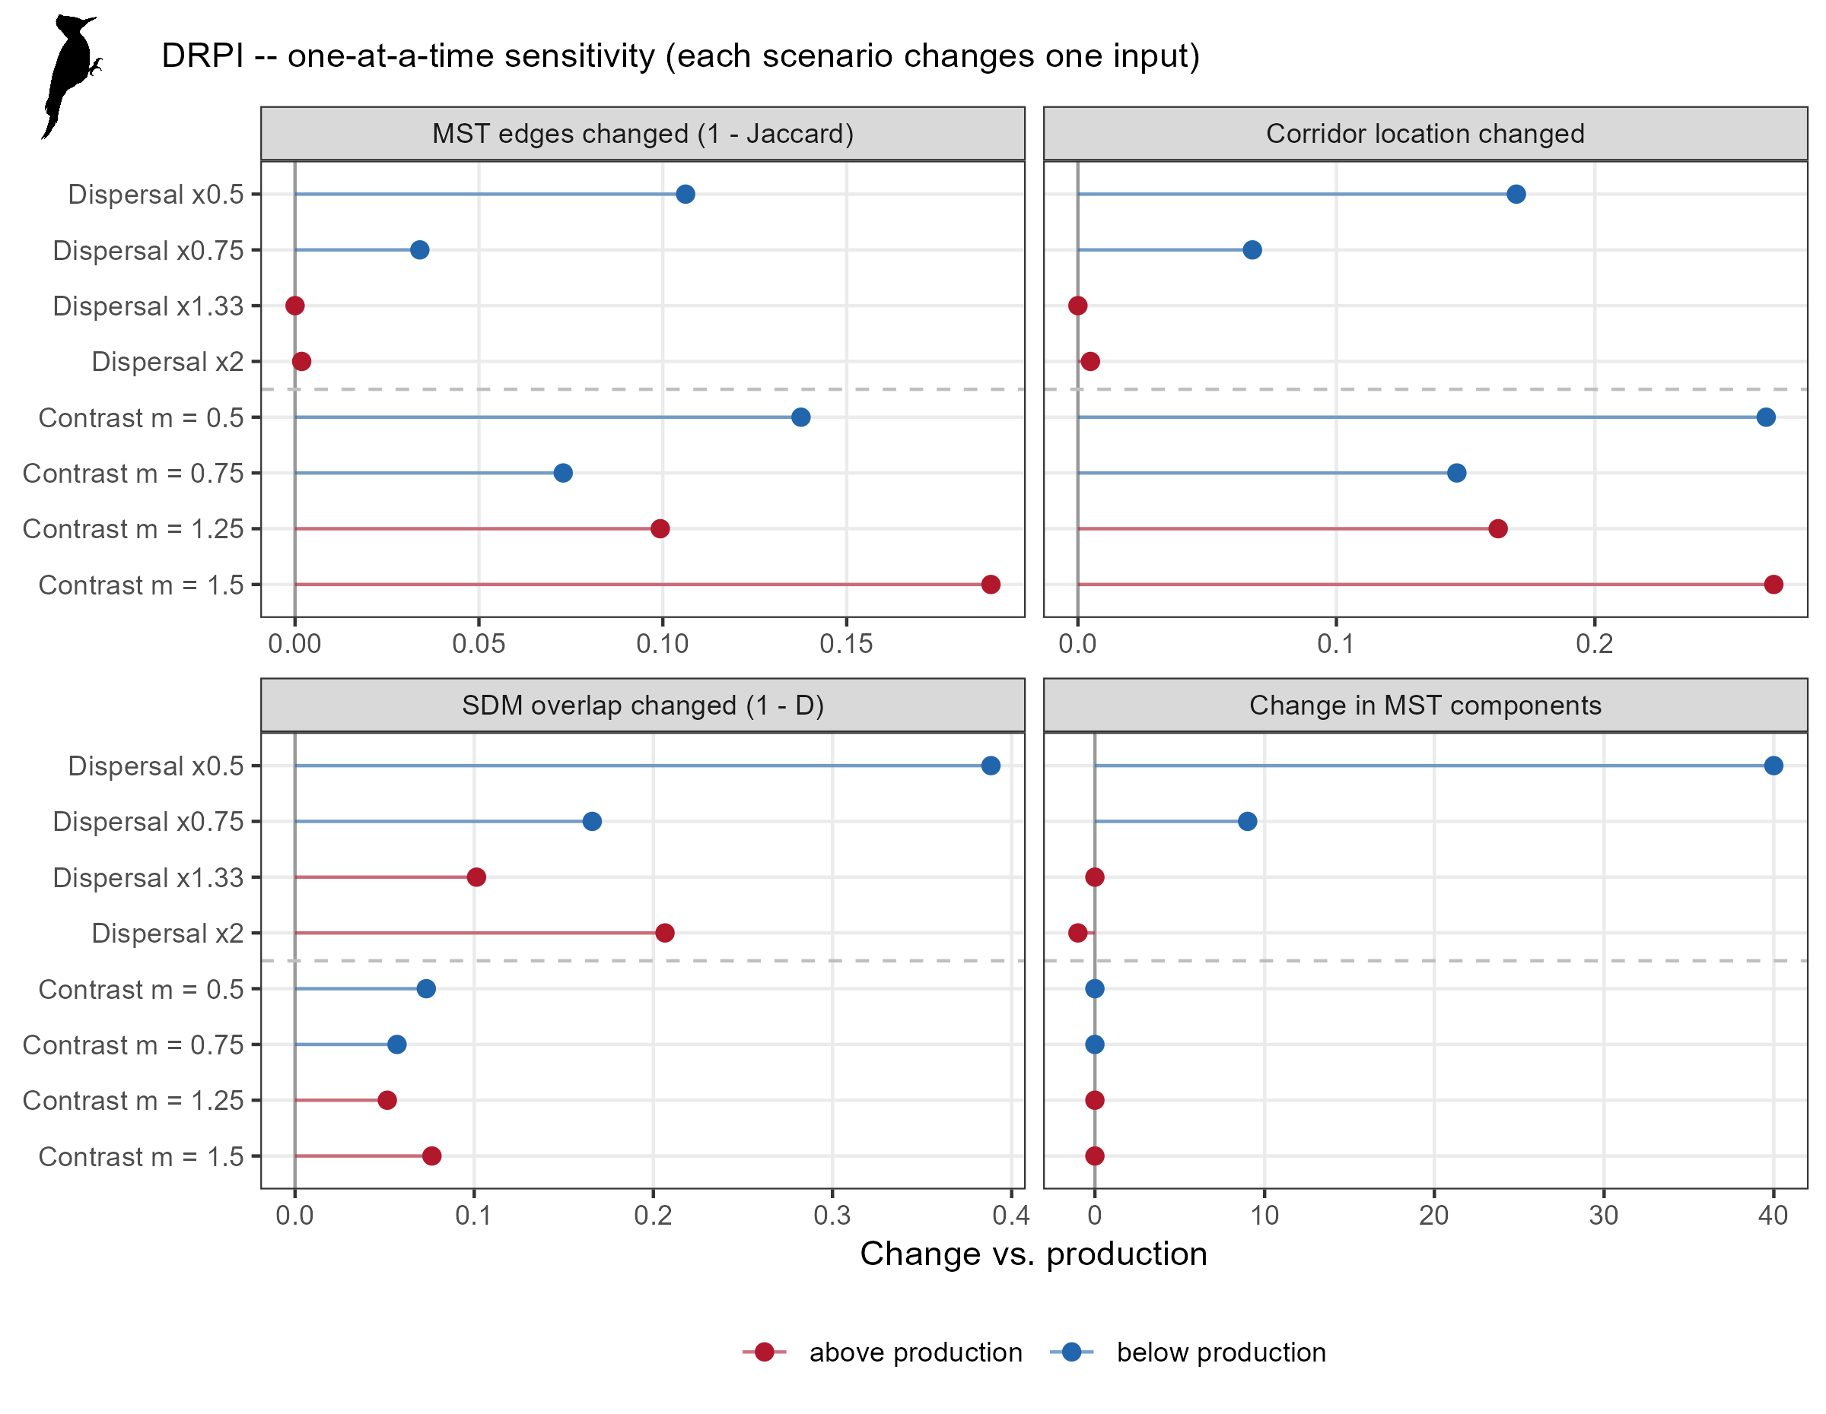
Figure S5. Effect of each sensitivity scenario on the pileated woodpecker results (see Section S7 for the panels).
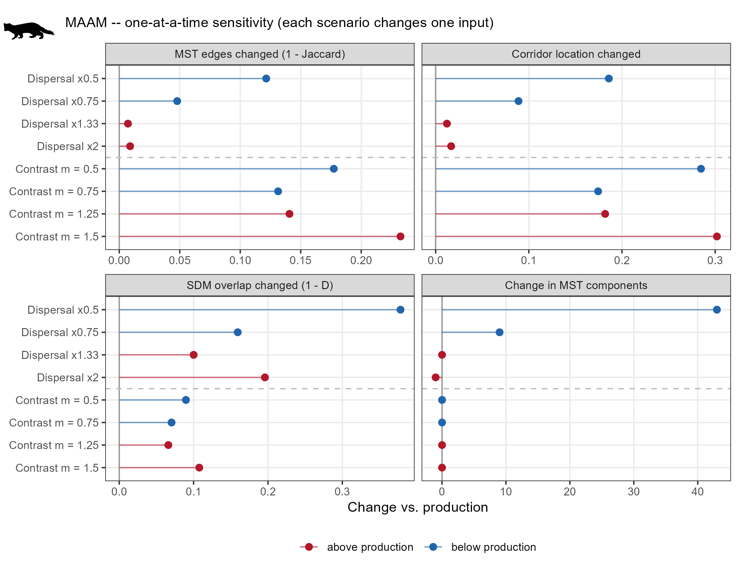
Figure S6. Effect of each sensitivity scenario on the American marten results (see Section S7 for the panels).
Deliverables
File paths are relative to the project folder. [sp] denotes the four-letter species code (Table S1).
Table D1. Deliverables and associated files.
Deliverable | Files | Status
Harmonized protected areas | data/intermediate/00_PAs/pa_model_5km2.shp, pa_model_10km2.shp; data/output_data/01_PA_patches/pa_patches.gpkg, pa_ctroidnodes.shp | Complete
Species traits and dispersal parameters | data/drive_data/specieslist.xlsx (“top10” sheet); data/drive_data/species_metadata.csv; data/drive_data/suitability/[sp]_landcover_rank.csv, [sp]_forest_type_rank.csv, [sp]_age_penalty.csv; output/tables/01_dispersal_kernel_params.csv | Traits for 10 species; dispersal table for 5
Candidate protected-area pairs | data/intermediate/01_PA_candidates/[sp]_PApairs_dkernel_cutoff.csv, [sp]_PApairs_edge_lines.gpkg | 5 species
Resistance surfaces (30 m) | data/output_data/02_resistance/[sp]_res.tif; output/tables/02_landcover_resistance_by_species.csv | 5 species
Pairwise cost distances | data/intermediate/03_cost_distances/[sp]_PA_costs.csv | 5 species
Minimum spanning tree maps and summary tables | data/output_data/04_mst/[sp]_mst_lines.gpkg; data/intermediate/04_mst/[sp]_mst_edges.csv, [sp]_mst.rds; output/tables/04_mst_summary.csv, 04_mst_edge_stats.csv | 5 species
Least-cost corridors | data/intermediate/05_lcp_corridors/[sp]_lcp_corridors.gpkg | 5 species
Corridor density maps | data/intermediate/06_corridor_density/[sp]_corridor_density.tif, all_species_corridor_density.tif | 5 species
Corridors integrated with species distributions | data/output_data/07_mst_SDM_overlap/[sp]_habitat_overlap.tif | 5 species
Sensitivity analysis | data/intermediate/08_sensitivity/[sp]/; output/tables/09_sensitivity_results.csv; output/figures/09_[sp]_sensitivity_tornado.png; data/output_data/09_sensitivity/[sp]_mst_edge_retention.gpkg, [sp]_overlap_variability.tif | Complete for 5 species (40 scenarios)
Report figures | output/figures/report_fig1_network_MAAM.png, report_fig2_corridors_MAAM.png, report_fig3_results_MAAM.png, report_fig4_trees_5species.png, report_fig5_sensitivity_MAAM.png, MAAM_corridor_sigma_vs_median.png; scripts/misc scripts/fig_results_document.R, fig_corridor_sigma_vs_median.R | Current
Code and documentation | scripts/ (setup_script.R, pipeline_functions.R, setup_species_from_xlsx.R, scripts 00–09); MST script workflow document.docx; MST results summary.docx | Current

